**2. GIT_HOL**

**Objectives**

* Explain .gitignore
* Explain how to ignore unwanted files using .gitignore

**Prerequisites**

Before starting:

* Git installed and configured (git --version to check).
* Notepad++ integrated as Git’s default editor:
* git config --global core.editor "notepad++"
* A local Git repository and a linked remote (GitHub or GitLab).

**Hands-On Steps**

**Step 1: Navigate to Working Directory**



**Step 2: Create Sample Files**

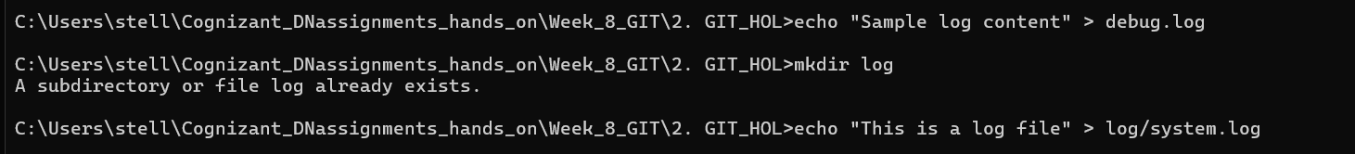

**Step 3: Create/Edit .gitignore**

Add the following:

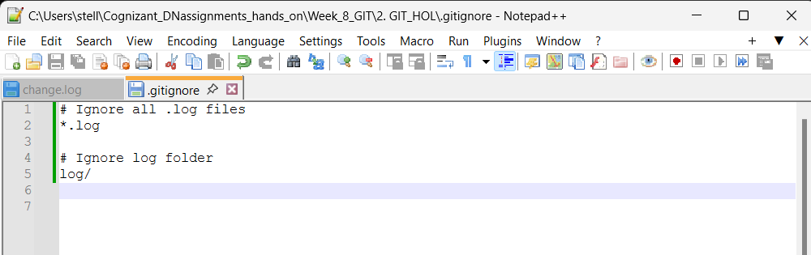Save and close.

**Step 4: Check Git Status**

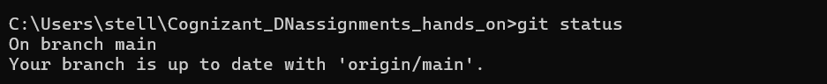

**Step 5: Commit the .gitignore**

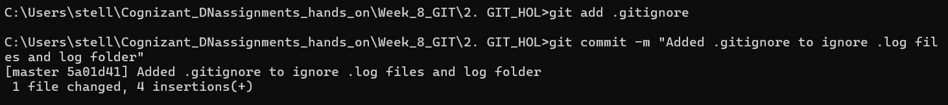

**Step 6: Push to Remote**



**Output Example**

